# Learning about urban climate solutions from case studies

William F. Lamb1*, Felix Creutzig1,2, Max W. Callaghan1,3, Jan C. Minx1,3

1 Mercator Research Institute on Global Commons and Climate Change, Torgauer Straße 12-15, EUREF Campus #19, 10829 Berlin, Germany

2 Technische Universität Berlin, Straße des 17. Juni 135, 10623 Berlin, Germany

3 School of Earth and Environment, University of Leeds, Leeds LS2 9JT, UK

* [lamb@mcc-berlin.net](mailto:lamb@mcc-berlin.net)

**Climate mitigation research puts increasing emphasis on cities. Yet in the assessment of urban climate solutions, much more could be learned from case studies. The overall size, geographic scope and topic content of urban case studies remains basically unknown, resulting in few attempts to synthesise the bottom-up qualitative evidence on mitigation prospects in cities. We use scientometric and machine learning methods to produce a comprehensive evidence map of urban climate mitigation cases. Our database of 4,051 studies provides a wealth of evidence to search, compare and review. We find that cities in world regions with the highest future mitigation relevance are underrepresented, while comparative analysis between cities and efforts to synthesize the existing case study evidence remain limited in scope. A map of the evidence allows case studies to be matched with urban typologies in new forms of synthesis, bringing together traditionally separate strands of qualitative and quantitative urban research. Such integrative research approaches are essential on the path towards a more synthetic global urban science.**

City-scale reforms in transportation, building design and urban form have substantial potential for reducing energy demand and achieving sustainability co-benefits. But when it comes to learning about appropriate policies, the key questions are: what works, for whom, under what conditions, and why? With no consistent epistemology, enormous variety in boundaries of analysis, and a lack of formal research synthesis, urban mitigation solutions remain diffuse and insufficiently specified 1–3.

Systematic learning hinges on aggregating information about individual cities. Recent work emphasises a quantitative direction to this work, using ‘big data’ and typologies to identify structural similarities and path dependencies of development 4. In this sense, groups of similar cities might draw from the same pool of solutions, or learn from early pioneers in climate policy. To make this strategy actionable, however, it will be critical to complement quantitative typologies with an understanding of underlying political and social conditions – the decisive factors that ultimately shape or hinder urban transformations 5.

A complementary strand of urban literature can be found in case studies: on individual city-scale reforms, as well as comparative studies across multiple urban settings 6. Using a variety of analytical tools, often qualitative, case studies can reveal the contextual and contingent nature of urban policy-making. Yet they remain under-represented in the scope of assessment literature on cities. The typical presentation of such evidence in assessments takes an anecdotal rather than analytical form – as dedicated boxed sections, as examples of particular phenomena, or within curated libraries of initiatives. A lack of rigorous literature selection procedures in assessments (and in reviews generally) means that potentially relevant cases remain overlooked 3. Above all, the potential for coordination and mutual learning across epistemic communities, global and data-driven on the one hand, bottom-up and case-based on the other, has been neglected.

Urban case studies can add to our understanding of climate mitigation solutions, but an overview of the field is urgently needed. Which cities do we know about? What topics do we know about? What comparative and secondary analysis is there of cases? And how can generalizable knowledge be derived from urban cases? In this perspective we address these questions, using literature mapping approaches to discover and characterise the existing case studies. Overall we identify a large and varied case literature, albeit one with regional and topic biases. To bring the policy relevance of cases to the forefront, we discuss the different opportunities they present for learning. We argue for more ambition in comparative studies, the need for systematic reviews of cases, and the potential to organise case study insights using quantitative typologies of cities.

As a starting point to our analysis, we obtain a sample of urban mitigation articles using a search query that combines synonyms for “urban” and “mitigation” in the Web of Science and Scopus literature databases (see methods). Our interpretation of case study research is straightforward: if an article mentions a city name in the abstract or title, we assume it is a case study located in the city (or cities) mentioned. We validate this assumption subsequently for a representative sample of cases. Our dataset for the proceeding analysis consists of 4,051 case study publications. We use language processing methods to extract relevant meta-data on case study locations, topics, review studies, and other information. In our article, this ‘mapping’ of the case literature is limited in analytical depth, but it is highly comprehensive in scope. The database of case studies we provide with this article thus enables researchers to ‘zoom in’ on particular topics or places of interest, with the intention of stimulating future work, refinement, and large-scale assessment.

## Urban case studies are biased towards large cities and the global North

Cities vary in many dimensions, including size, income and levels of access to different infrastructures (such as public transportation and energy services). As different types of cities face different challenges, learning about solutions depends on a balanced coverage of case study research. An obvious question therefore arises: which cities do we actually know about?

Figure 1 shows the spread of case study research across four different city sizes, from a small number of familiar ‘mega-cities’ (over 10m inhabitants), to large cities between 1-10m, to hundreds of medium (0.3-1m) and smaller (<0.3m) cities. The majority of research so far has focused on larger cities, with a number of specific mega-cities receiving particular attention: Beijing (369 articles), Shanghai (194), New York (161), London (128) and Tianjin (101). Other cities are mentioned in fewer than 100 articles each.

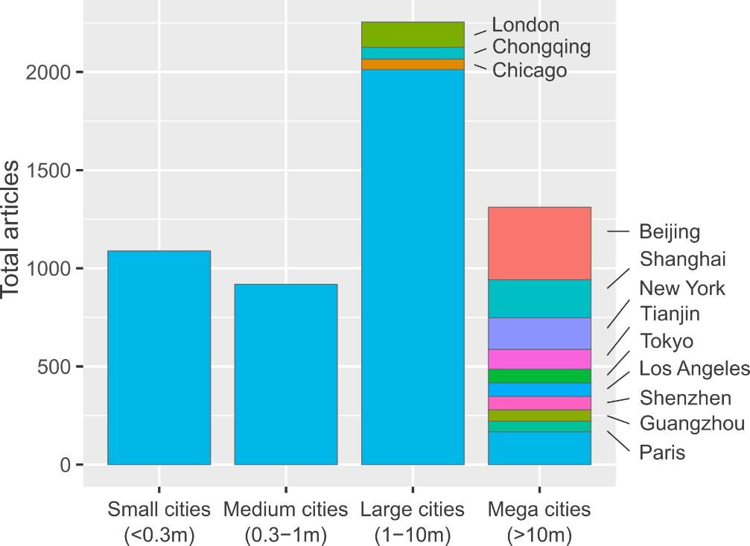

**Figure 1: Number of urban climate mitigation case studies, grouped according to city size.** The 12 most frequently studied cities are labelled. Population data from ref 7, using agglomeration data where available.

Considering the global distribution of population, the current focus on larger cities does not seem to be justified. Just 12% of the world’s urban population lives in mega-cities, compared to 43% in small cities – yet both groups are treated almost equally in research, studied respectively in 23% and 19% of cases (Figure 2). A particularly stark divide can be seen in Asia, where the low proportion of mega-city inhabitants (7%) is served by over 40% of the urban case study literature in this region. Although mega-cities are fast-growing in most regions (SI Text Figure 1) this unbalanced focus leaves smaller urban centres consistently under-represented in all regions apart from North America.

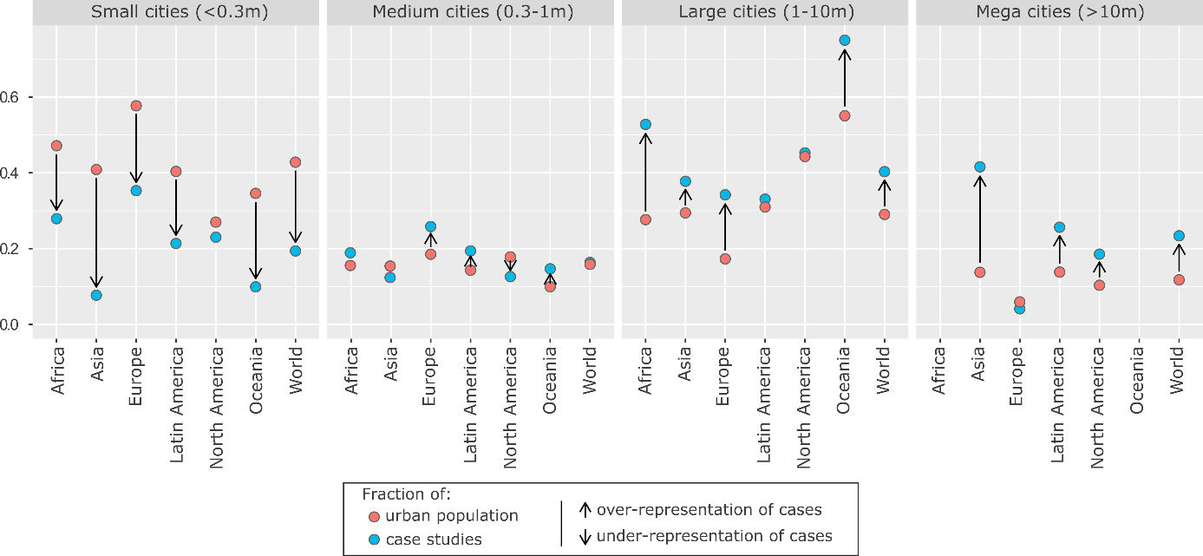

**Figure 2: Size bias in urban mitigation case study research.** Fractions of population and case studies are relative to regions. Population data and the United Nations Population Division regionalisation are from ref 7, using agglomeration data where available.

Regionally, we also observe a clear bias towards Europe, North America and Oceania, which receive an outsized share of articles relative to their small proportion of the global urban population (SI Text Figure 2). Looking forward to urbanisation trends in 2030, the least well represented region, Africa, has the fastest growing cities (SI Text Figure 1). And one of the least well represented segments, small Asian cities, will have the largest share of the global urban population (SI Text Figure 3). Hence, the world regions and city scales with most future relevance in terms of total urban population and growth dynamics are systematically underrepresented in the literature.

With the window on the 1.5°C and 2°C goals rapidly closing it is essential to immediately initiate urban infrastructure transformations and comprehensive low-carbon retrofitting, worldwide. The current focus of case study research on wealthier and high-emitting cities is congruent with current debates in climate ethics: that responsibility for drastic mitigation action rests on the shoulders of high-emitters 8. Nonetheless, a high proportion of future urban emissions growth will originate from up-coming Asian and African cities, where ongoing processes of urbanization and infrastructure development provide a window of opportunity for establishing urban designs consistent with low-carbon mode choices and building use 4. Guiding these growing cities towards compact, low-carbon urban forms requires a major shift in research focus. Although we do observe an uptake in case studies on Asian cities since the IPCC 5th Assessment Report, there has been only a very limited expansion of cases on African and Latin American cities in recent years (SI Text Fig 4).

Redressing the lack of focus on smaller cities emerges as a second priority. Yet herein lies a more fundamental problem: whereas large cities are few in number and can be reasonably sure of dedicated case studies that address specific policy needs, smaller cities are far more numerous, rendering direct coverage of all such cities near impossible. Almost 60% of global mega-cities (17/29) are directly researched in our database of case study literature. This figure declines to 25% (303/1228) for medium-sized cities (SI Text Figure 5). We can safely presume that coverage is even worse for small cities, even though data on the number of these remains incomplete. As a result, learning about solutions across a comprehensive set of contexts and scales requires major innovations in the synthesis of case study knowledge.

## A topic map of urban mitigation case studies

Urban climate mitigation is a broad church, encompassing research on a variety of sectors (e.g. buildings, transport, waste), policies (infrastructure provisioning, behavioural incentives) and overarching concerns (social and environmental sustainability 9). The relevance of a particular research stream for policy learning depends on the cities and context at hand. Some urban issues are known to be ubiquitous – car-centric transportation infrastructures often result in a variety of harms to human health, civic life and equal access to services – while others are far more location specific, such as high heating demands in northern latitudes, or climate adaptation needs in low-lying coastal cities. Understanding the scope of mitigation research carried out on cities is an entry point to structured learning on solutions.

However, it is increasingly difficult to track the development of rapidly growing scientific fields. We therefore turn to natural language processing methods to explore the thematic content of urban case studies. Using the identified corpus of 4,051 case studies we construct a matrix of documents and the words contained in their abstracts, factorising to obtain the ‘topics’ that describe commonly co-occurring words across the document set (we subsequently refer to this as “topic modelling”; see methods). In essence, machine reading software discovers the latent topics that permeate the document set and categorises each document accordingly, substituting for the laborious task of reading and tagging each article by hand.

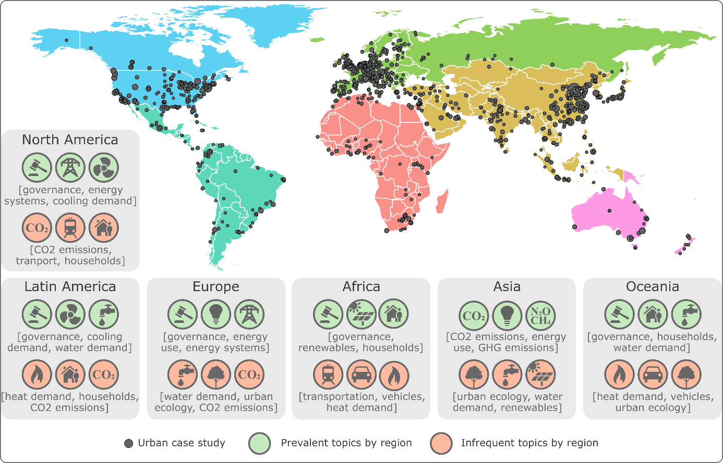

**Figure 3: Global coverage of urban case studies.** Cities are scaled by the number of identified case studies. For each region, the topic distribution of associated case studies is summed, and the highest/lowest scoring topics are shown (see Methods).

Demand-side topics (i.e. those that focus on end-use sectors and behaviours) are prevalent in case studies. These include transportation, waste management, and energy, heat and cooling demand in buildings – alongside issues of urban climate governance, urban form and CO2 emissions accounting (Figure 4; SI Text Table 1). Of the 16 topics we identify, only two focus on supply-side mitigation – on energy systems (e.g. grid management and storage) and renewable energy (most prominently, solar PV). Because topic modelling ascribes multiple topics to each document, combinations of issues can be found. Hence we also see a wider set of sustainability concerns represented alongside urban mitigation issues, such as water demand and urban ecology.

Topics are not evenly distributed across different urban regions. Scaling up the analysis from individual documents to groups of documents, we observe that emissions and energy accounting is a frequent subject of case study research situated in Asia (Figure 3), perhaps reflecting strong investments into engineering disciplines and education in China and South Korea (44% of all students in China graduate in science & engineering, compared with 16% in the US) 10. This contrasts with the ubiquity of urban governance research, capturing research on policies and policy-making, in all other regions.

Where individual cities already have large literatures, particular topic trends can also be observed. Figure 4 presents the distribution of topics within the 10 most studied cities as a heat map. Low-carbon transportation case studies are well developed for Beijing, Shanghai and London, but scarcely researched in New York City, where cases have a greater focus on buildings. Emissions accounting dominates the case study work on top-tier cities in China (Beijing, Shanghai and Tianjin), while issues of water demand, urban ecology and climate governance receive less attention – at least in the mitigation focused literature we identify from Web of Science and Scopus. Table 2 in the SI text lists the 9 articles we identify for the largest urban centre in Africa, Cairo, showing not just the scarcity of studies on this city, but the potential of topic modelling to rapidly expose the main research to date, in this case a relatively narrow focus on building design.

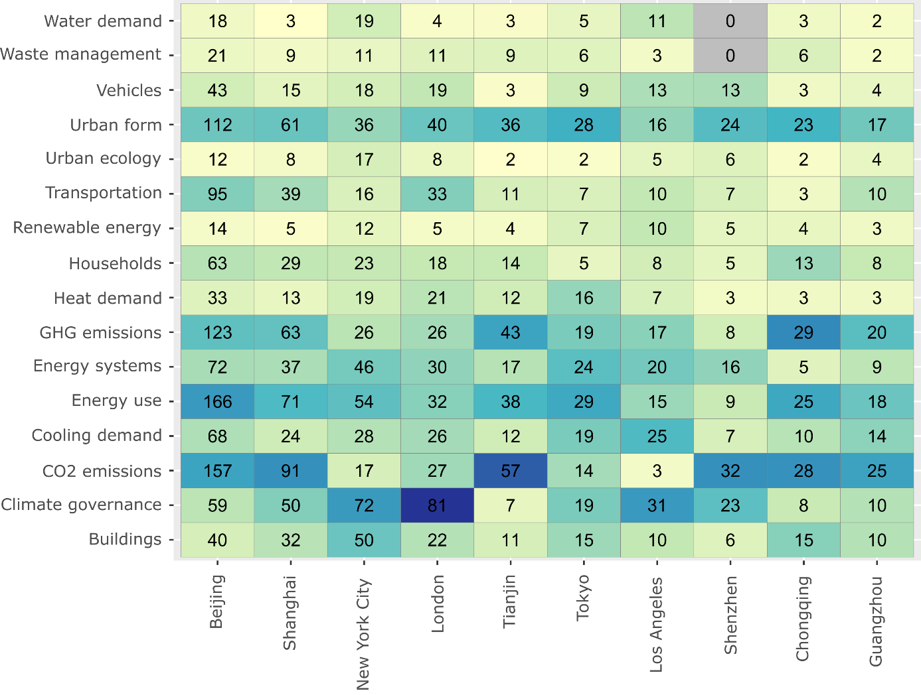

**Figure 4: Number of mitigation studies by city and topic.** 10 cities with the most publications are listed. A city/topic combination is counted if the publication meets a minimum topic threshold of 0.02 (see Methods). Publications with multiple topics are double-counted, often when topics are strongly correlated (e.g. Energy use and CO2 emissions). The colour scale is normalised by city, indicating the main topic focus of case study literature within each city. Note: because our literature search included keywords only for climate mitigation, indicated studies are not comprehensive, particularly where large and relevant sectoral literatures exist but are not yet framed in terms of emissions reductions (e.g. transport) 6.

A key mitigation topic and bottleneck in reaching very low levels of energy demand is urban form –i.e. the spatial characteristics of a city, including density and land-use configuration 11,12. Urban form is indeed one of the most prevalent topics in the set of case studies (SI Text Table 1). An important question is whether future urbanisation challenges related to urban form are being anticipated and mitigated, rather than responded to post-hoc. We therefore search abstracts directly for keywords that might indicate such “forward looking” studies (e.g. “scenario” or “2050”; see methods for more detail), finding 750 documents that mainly emphasise GHG emissions accounting, climate governance, energy consumption and transportation (SI Text Table 3). Notably, urban form is less prominent, and the fastest urbanising region, Africa, is particularly under-represented in this subset of documents. Just 8% of the case study literature in Africa takes a forward looking orientation (12 studies), contrasting with an average of 16% in other regions (SI Text Table 4).

Policy focused cases associated with the “climate governance” topic tend to refer to mitigation action plans, multi-level coordination and generic governance issues (SI Text Table 1). Pricing and economic analysis appears to be only a marginal topic in the urban case study literature (as pointed out by a reviewer of this manuscript), despite the importance of fuel prices as a long-run determinant of urban form and GHG emissions 4,13.

Overall, the topic mapping results suggest that prior regional biases in case study coverage are compounded by an uneven distribution of topics: given the already limited extent of research on African cities, topics are spread thin. Only a handful of urban cases in Africa can be found on issues that will likely have great importance in several decades, such as urban form and transportation. In contrast, some mega-cities already have well-developed literatures across a spread of topics. Together this suggests priorities for further primary research, as well as a substantial scope for consolidating and learning from the current evidence.

## Three ways to learn from case study evidence

Mapping out the literature provides a starting point for in-depth synthesis. Here we consider the various ways to best make use of the growing body of case studies: as individual studies, in comparative settings, and within reviews and assessments. Our review is guided by two questions: what are the different opportunities for generalisation in each approach? And how are cases actually used by urban stakeholders, researchers and policy makers?

### Individual cases

Case studies attract their fair share of epistemological debates. Some quantitatively oriented scientists tend to dismiss case studies due to their perceived deficiencies in generalisability, relative to quantitative methods such as regression analysis 14. Because an individual case study speaks only to the context at hand, it seemingly cannot inform contexts elsewhere. Case study proponents, on the other hand, emphasize the importance of careful case selection to support generalisability, as well as the intrinsic value of conducting cases for learning 14–16.

An example of careful case selection is the *critical case*. Here researchers aim to demonstrate that if X is possible (or impossible) in the critical case, it is also so in all cases. For instance, to demonstrate the technical feasibility of strongly reducing energy demand for space heating, the critical case would be an extremely cold urban climate, rather than a mild one 17. An alternative strategy is to identify cases on the merit of *influence* – i.e. they simply matter for the wider system under study 14. Investigating the consumption-based emissions of mega cities might be easily justified in this manner, on the grounds of their influence on the global carbon budget 18,19. *Paradigm, deviant* and *random* cases are other potential choices to support claims of generalisability 15.

But when it comes to selecting case study locations, practical concerns matter too. We cannot ascertain the motivations behind the case selections documented in this article, but their strong geographic and topic biases do suggest certain practical limitations. The dominance of North American and European universities in scientific publishing, as well as institutional funding biases, limited scientific capacities in the global South, and everyday travel limitations are all possible factors that confound the selection of cases on strong theoretical merit.

Nonetheless, Flyvberg makes a strong argument for the intrinsic value of conducting case study research, as a means to build expertise 15. Case study methods require a deep engagement with actual reality, forcing researchers and practitioners to critically reflect on rule-based knowledge – such as whether theoretical perspectives in the discipline are relevant in a given case. In a similar vein, case studies can hone expertise through direct engagement with urban stakeholders, enabling mutual learning between policy-makers and researchers in diverse forums of science-policy exchange 20. Not least, case study reports have rhetorical strengths and are particularly well suited to engaging lay audiences, being formulated around narratives and concrete phenomena, rather than abstract or technical theory. In sum, the practice and deep reading of case studies enables urban practitioners to hold a breadth of context-dependent knowledge at their fingertips – a basic precondition for true expertise 15.

There are therefore many benefits to be derived from individual cases, but also risks. Cases are increasingly buried amid thousands of disparate articles across hundreds of journals; they risk being overlooked, or duplicated in popular settings and topics. To ensure learning from the different types of cases – critical, paradigmatic, deviant – and to enable comparative analysis of cases within similar settings, dedicated efforts are needed to map them out and bring full transparency to their locations, topics and methodological choices.

### Comparative cases

A second common approach in the design of case studies is to implement a single methodology across multiple case locations. These comparative case studies have the advantage of enabling direct tests of generalisability, by identifying common patterns. For instance, evidence from a comparative study of 4 cities underscores the crucial need to restrict car traffic rather than rely on advancing public transit alone to decarbonize urban mobility 21. Another study found that across 4 cities, urban leaders retain influence over the composition and magnitude of a large portion of upstream (consumption-based) greenhouse gas emissions 19.

Comparative research is also of deep interest to urban stakeholders, who may wish to understand how their peers commit to and overcome barriers in climate change mitigation. This is the basic premise behind urban cooperation groups such as C40 and ICLEI, which actively document and compare urban actions through case studies 22–24; and action tracking initiatives such as the Global Climate Action NAZCA portal 25.

There is substantial comparative work analysing mitigation and adaptation plans across hundreds of cities 26–28, and more detailed studies published as volumes 29,30. Much attention is also paid to comparing urban carbon footprints 31–33. Less known are the small-n comparative studies. What proportion of the literature do they constitute? And for a given city or topic, what comparisons have been made? Automatic analysis of the literature can identify which case studies refer to more than one city in their title or abstract. These make up approximately 18% of the literature in our sample (721 cases). The majority of comparative cases mention only two cities (409), with a steep decline to only a few dozen studies on 5 or more cities (SI Text Figure 6).

Inter-regional comparisons are relatively rare. Figure 7 in the SI text visualises the pairwise correlations of cities within abstracts, aggregating by region. Asian cities tend to be compared to other Asian cities, European cities to European cities, and likewise in North America. Studies on Latin American, African and Oceanian cities, on the other hand, are more frequently paired with cities in other regions, but are fewer in number. Considering the total scope of the urban case study literature (4,051 studies), the subset that is comparative (702 studies), and internationally comparative across more than 2 cases (67 studies), is small.

As with individual cases, mapping and transparency are key to making best use of the comparative case study literature. While topics and study locations can be straightforwardly identified, the epistemological choices underpinning comparative research are very difficult to ascertain. Based on a random selection and review of documents, we find little justification for why particular cities are bundled together, beyond claims of contextual diversity. Again, these decisions may be driven by pragmatic concerns (such as funding and research partners) rather than strong comparative logics, underlining the still nascent stage of urban sustainability science 34.

### Reviews and assessments of cases

A third opportunity for learning from cases is through secondary analysis in literature reviews and assessments. Concise, policy-relevant advice based on the literature is in high demand from stakeholders. Such reviews and assessments can be particularly effective when stakeholders are involved at the design stage to communicate their knowledge needs 22,35. In the area of urban climate mitigation, there have been several assessments so far and growing activity. The Global Energy Assessment provided one of the first dedicated reviews on urban energy systems and was followed by an urban chapter in the IPCC 5th Assessment Report (AR5) 36,37 and two assessments by the Urban Climate Change Research Network (UCCRN) 30,38. In the upcoming IPCC AR6, urban case studies will be a key evidence base for both the urban and demand chapters in Working Group III (Mitigation), not to mention the regional chapters under Working Group II (Impacts & Adaptation).

The Second Assessment report by UCCRN is a good example of the opportunities and challenges of learning from case study research. 117 case studies were produced for the report and submitted to the UCCRN online “docking-station”. This process ensured a standard documentation format, bringing transparency in the location, topic, studied actions and drivers, and lessons learned for stakeholders. The case study compilation was also part of a larger effort to derive comparable geographic, climate and socio-economic data on the studied cities. Cases can be searched and grouped by these variables in the online database, facilitating comparative analysis.

Although the UCCRN generated many new cases, they are simply placed throughout the report in boxed sections. In other words, the case content is brought to the forefront, but isn’t synthesized across topics or locations. This pattern is repeated in the recent IPCC Special Report on 1.5°C, which dedicates multiple pages to urban case studies in boxed sections (e.g. boxes 4.1, 4.4, 4.5 and 4.9). A prominent example is Box 4.5 on congestion charges, which describes three successful cases of implementation (Singapore, Stockholm and London), but neither compares nor synthesizes these examples with cases on failed proposals, such as in New York City and Edinburgh 39,40. As a result, little is learned about the circumstances for success or failure, despite a large underlying literature.

In fact, dedicated reviews of the case literature are rare, especially those using systematic approaches. Systematic evidence synthesis methods – those that deploy transparent and reproducible procedures for literature selection, quality assessment and synthesis – are the gold standard for generating a robust evidence base for policy 41–43. These consist of a wide spread of quantitative, qualitative and mixed review approaches that are well-documented in the health sciences literature 44.

Searching the original set of documents identified in our urban mitigation query (15,027 articles) for review articles, we identify just 13 studies that apply formal evidence synthesis methods (see methods). The majority are narrative reviews (SI Text Table 3): akin to a normal literature review, but proceeding from a documented search and selection of the literature. Four studies apply quantitative synthesis methods: a single meta-analysis of residential demand-response programs 45, two studies that extract and analyse quantitative information from literatures on urban ecosystem services 46,47, and a fourth that conducts secondary analysis on published scenarios 48. We only find a single study that refers to systematic *case study* synthesis methods: a case meta-analysis of 29 studies that examines the preconditions for meaningful urban energy transitions 49. Further methods such as qualitative comparative analysis and case surveys 50 are absent, although there are a few examples of these being applied directly to urban data (but not to the extant literature 51.



The absence of evidence synthesis on urban case studies is consistent with the wider field of energy studies and climate change mitigation 3,42 – and unsurprising given the challenge of varied case study methods, locations and scales. Thus while climate assessments increasingly assess the available literature on cities 30,36,52, learning appears limited as a crucial layer of evidence synthesis is missing. Detailed systematic maps of the available case study evidence as provided here are an important starting point 53. Indeed, stakeholders and decision makers are often interested in ‘mapping’ type questions (e.g. *What policies and measures have been studied? How much evidence is there on outcomes?*) 54. Case study maps therefore ought to be developed alongside future assessments by the IPCC and UCCRN. But more than this, new innovations are needed in knowledge synthesis to make best use of the developing literature.

## Synthesizing urban typologies and case study evidence

Urban typologies – taxonomies of city types – are powerful tools for comparing and aggregating knowledge on cities while preserving elements of context. Here we claim that typologies partnered with case studies could enhance learning on urban climate solutions, on the basis that similar structural conditions (i.e. captured through typologies of urban form, socio-economic development or types of governance) imply similar solution spaces. The Atkins *Future Proofing Cities* report pioneered such an approach by grouping 129 cities into 5 different types (based on qualitative criteria), linking these to more than 100 different policy options 55. In the academic literature typologies have proliferated, using newly compiled databases, as well as spatial, crowdsourced and ‘big’ data 4,32,56,57. However, as yet there have been no systematic attempts to link typologies of cities to case study knowledge, and on this basis aggregate tailored policy advice.

Typologies are highly complementary with the case study method 58. They narrow the universe of cases that can be meaningfully compared, such that detailed case studies on specific types of cities can be generalised to a wider set of shared contexts. This holds the promise of stimulating learning within peer groups of cities, as was attempted in the Atkins report and in similar efforts led by ICLEI, where cases on infrastructure transitions have been assessed for post-industrial cities 23. But qualitative information from accessible and synthesized urban cases may also directly improve typology development itself. Linking together detailed case studies within a typology framework therefore allows a series of policy relevant questions to be asked, such as: what structural urban conditions shape energy demand? Within relevant peer groups, what intervention points exist for reducing energy demand in the short, medium and long term? Within relevant peer groups, which cities have enacted climate policies, were they successful, and why?

Typology efforts in the peer-reviewed literature so far have largely focused on drivers of energy demand and greenhouse gas emissions, mobilising data on urban land use, urban form and street patterns, income, energy demand and travel behaviours. Qualitative typologies that focus on the available policy option space are still missing. These would group cities that share similar institutions and governance (e.g. the areas of policy over which cities have executive power; their available municipal budgets), social priorities (e.g. infrastructure or service access) and political constraints (e.g. the balance of private and corporate interests).

What methods could bridge urban typologies and case study evidence? In the first instance, a systematic mapping of the literature in combination with available typologies can be used to identify the available cases within peer groups, specifying knowledge clusters and gaps at a higher level of policy relevance than size and regional classifications. As a demonstration, Figure 5 links the case study literature identified here with a typology of city types characterised by their drivers of energy use (from ref 4). In this clustering, the cities with the lowest energy use per capita, such as Ahmedabad (Type 3) are characterized by high population densities, low incomes, medium-high fuel prices, and a low number of heating degree days. Cities with highest energy use, such as Sydney (Type 5), are characterized by very low fuel prices and medium-high incomes (for quantitative values see 4).

Assessing the case studies in light of this typology underscores again the dearth of evidence on specific city types, across the entire spectrum of low (#3), moderate (#1, #2) and high (#5, #8) patterns of urban energy use. Nonetheless, there is some congruence and opportunities for synthesis in the topics studied: urban form in sprawling, energy intensive cities (#5), heat demand in colder climates (#2, #8), and a spread of topics around governance, energy systems and energy use in wealthier Northern cities (#6, #7).

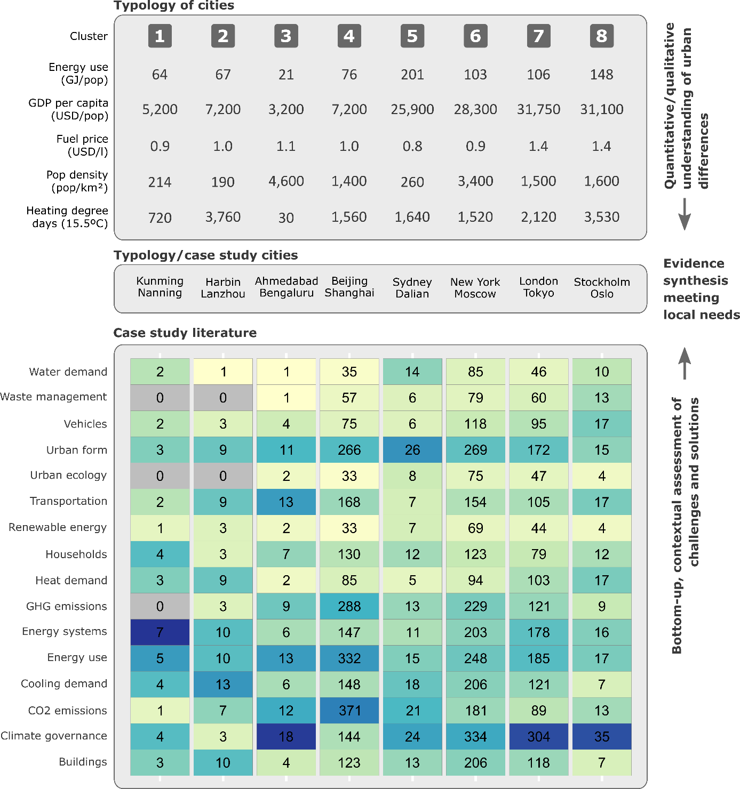

**Figure 5: Bringing together case study evidence and typologies.** The typology and its data are from ref 5 (see also for uncertainty ranges); case study literature and topic analysis from this study. As in Figure 4, a cluster /topic combination is counted if the publication meets a minimum topic threshold of 0.02 (see Methods). Articles with more than one highlighted topic are double counted. The colour scale is normalised by typology cluster, indicating the main topic focus of case study literature within each cluster.

Beyond this basic mapping, in-depth evidence synthesis methods could be applied in parallel with typology approaches. Case surveys, case meta-analysis and qualitative comparative analysis are methods for extracting and coding individual study features such as design, context, results and other information, allowing structured comparisons and even quantitative analysis across cases 50. These methods could capture qualitative contexts that are so far missing from urban data science, enabling typologies to be tested and brought to a higher level of explanatory and comparative power. There are of course constraints in terms of available data and cases, which are sparse for smaller cities and particular clusters. Crowdsourcing and spatial methods are already closing data gaps in these cities 33; such efforts need to be matched by a shift in case study focus. Yet the proposed approach promises to address a key issue therein: what are the peer groups for smaller cities? With the predominant focus of cases and comparisons on a set of familiar mega-cities (often sharing quite similar attributes), it is far less obvious how comparative work can be adapted for a much larger set of small and medium-sized cities. By narrowing the scope of peers, and bringing cases that do exist to the forefront, typologies provide the entry point to the systematic comparisons of smaller cities that are currently missing.

## Conclusion

Global, quantitative studies can identify such solutions in part 4,32,59.Case studies can do the work, with their targeted focus and varied opportunities for generalisation and learning. But despite many recent commentaries highlighting the manifold challenges (and opportunities) of an urban focus in climate mitigation 1,60–64, there has been little reflection on how to generate insights from cases using additional layers of mapping, comparison and synthesis. Dedicated efforts in these areas, integrating cases in a wider project of learning, will generate substantial value for scientific assessment and urban practitioners of climate change mitigation.

Urban climate assessments have suffered from the anecdotal use of cases and a poor overview of the available evidence base. We identify 4,051 studies to date and make them available for systematic assessments in the future. Since we captured only ‘climate mitigation’ articles in a broad brush approach and limited our efforts to the Web of Science and Scopus as two of the largest scientific publication databases, this is still an underestimate that does not reveal the full extent of sector- and country-specific research 6. Manually scoping this number of studies to gain an overview of the field would be difficult and highly time consuming. But with computer assisted methods, including scientometrics and computational linguistics, a comprehensive evidence map can be developed more quickly and subsequently built upon as a community effort. In doing so, we substantiate claims of a North/South bias in cases with a comprehensive sample of the literature 64, while going further to identify patterns of research that favour large cities and overworked topics (such as emissions accounting in Asia), to the detriment of others (current and future urban form in Africa).

These issues require a shift in focus, including a diversification of contexts and topics. Locating research efforts, stakeholder engagement and policy advocacy in growing cities and developing regions will be instrumental to avoiding lock-in and realising compact, low-carbon urban forms that can tackle the coming mitigation challenge 12,36,65. Doing so would resonate with calls to develop global urban solutions and ‘leave no city behind’ in scientific assessments 1,2,61,66.

More attention should be given to learning from case studies. Some opportunities have yet to be fully realised, particularly in the area of evidence synthesis. In this regard, inspiration might be drawn from other fields of scientific inquiry, where large case literatures exist and challenges of aggregation are common, such as in urban adaptation research 67 and land-use science 68. Our analysis reveals that juxtaposing evidence synthesis with quantitative city typologies can be a productive way forward to bring quantitative and qualitative research on cities and climate change solutions together. Aggregating cases and their insights to the level of urban typologies has already started in the grey literature, but remains undeveloped in peer-reviewed work and assessments. Above all, a culture of learning and synthesis is called for: from investigating unknown contexts, to making individual case studies available for systematic reviews, to increased ambition in comparative research, to more comprehensive reviews of the case study literature. These are public goods that require significant investments in time and effort. But for a truly synthetic global urban science, no case study should be left behind.

**Methods**

*Literature scoping*

A search query combining ‘urban’ and ‘mitigation’ synonyms was used in the Web of Science and Scopus to identify relevant documents (Table 2). As of October 2018 this search returned 15,027 documents (unconstrained by language or document type).

|  |  |
| --- | --- |
| Urban synonyms | Mitigation synonyms |
| ("urban*" OR "municipal" OR "city" OR "cities" OR "metropolitan") | ("low carbon" OR "decarboni*ation" OR (("energy" OR "carbon" OR "CO2" OR "GHG" OR "greenhouse gas" OR "climat*") NEAR/3 "mitigation") OR (("energy" OR "carbon" OR "CO2" OR "GHG" OR "greenhouse gas") NEAR/3 ("reduc*" OR "polic*" OR "governance"))) |

**Table 2: Search query for urban climate mitigation literature.** The two strings are combined with an ‘AND’ operator and entered as a topic search in the Web of Science, and a title-abstract-keyword search in Scopus.

Our results are not fully comprehensive, since further databases are available (e.g. Google Scholar) and relevant non-English language articles may exist. However, on translating our query into Spanish and French, and applying all versions in Google Scholar, we find very few further results, even from the “most relevant” documents – and no further peer-reviewed documents were identified. More in-depth studies, e.g. systematic maps on specific topics or cities, could consider additional databases and non-peer reviewed sources.

*Identifying cases*

To identify urban case studies we searched the abstracts of the 15,027 documents for city names. We use the Geonames database of geographic locations, which aggregates national survey data, travel destinations and open sourced contributions, specifying a global list of cities with populations greater than 15,000. 4,051 studies in the document set refer to a city in the abstract or title. Double counting where an article mentions multiple city names, we obtain 5,570 case studies on individual cities. We excluded conference proceedings, and the text “Paris Agreement” and “Kyoto Protocol” from abstracts to avoid false hits that refer to these climate treaties. The full database of case studies can be found in the supplementary materials to this article.

*Topic modelling*

We use the sklearn library in python to process and produce a topic model from the 4,051 studies mentioning a city in the abstract 69. Weighting terms in each document by the inverse of the number of times they appear across the corpus (tf-idf), we apply non-negative matrix factorisation 70 to a matrix of documents × terms. The resulting matrices, whose product approximates the document-term matrix, are used to label documents by topic, and topics by term. Higher document-topic scores indicate documents where words associated with the topic appear; higher topic-term scores indicate the strength of an association between a word and a topic. The marginal topic distribution for each topic denotes the sum of document-topic scores for that topic as a proportion of the sum of all document-topic scores.

Important and subjective choices in the analysis are the number of topics to specify and the names given to the resulting topics. We review multiple topic models in the range of 15-25 topics, choosing 17 due to the marginal (subjective) gain in information given by an additional topic. 1 of the 17 topics is manually removed, as this was synonymous in content (but not terminology) with another topic. We manually assign names to the topics (shown in SI Text Table 1), based on a review of the associated keywords and strongly correlating documents.

To analyse the prominence of topics within groups of papers (Figure 3), we sum their topic scores, selecting the top 3 for simplicity. In part, these results will be driven by the general prominence of topics across the whole document set (e.g. ‘governance’ more likely appears as a prominent topic than ‘urban ecology’). To count publications on given topics (Figure 4), we assign a document-topic score threshold of 0.02, reviewing a random sample of papers to confirm this choice.

*Future-looking case studies*

To identify case studies with a future-looking orientation (mitigation scenarios, for example, or projections of urbanisation, land-use, or energy demand), we manually search for the following keywords within abstracts: “scenario” OR “2020” OR “2025” OR “2030” OR “2040” OR “2045” OR “2050”. A random selection and screening of these documents showed they were broadly in line with our expectations.

*Systematic reviews*

To identify systematic reviews of the case study literature (Table 2) we manually search the original document set (15,027 studies) for the following keywords: “ meta-“ OR “systematic review” OR “scoping” OR “narrative review” OR “qualitative comparative analysis” OR “QCA” OR “scientometric” OR “synthesis”. The results are hand filtered to exclude non-urban, non-mitigation and non-review articles.

# References

1. Acuto, M., Parnell, S. & Seto, K. C. Building a global urban science. *Nat. Sustain.* **1,** 2–4 (2018).

2. Acuto, M. & Susan, P. Leave no city behind. *Science (80-. ).* **352,** 873 (2016).

3. Minx, J. C., Callaghan, M., Lamb, W. F., Garard, J. & Edenhofer, O. Learning about climate change solutions in the IPCC and beyond. *Environ. Sci. Policy* **77,** (2017).

4. Creutzig, F., Baiocchi, G., Bierkandt, R., Pichler, P.-P. & Seto, K. C. Global typology of urban energy use and potentials for an urbanization mitigation wedge. *Proc. Natl. Acad. Sci.* (2015). doi:10.1073/pnas.1315545112

5. Grandin, J., Haarstad, H., Kjærås, K. & Bouzarovski, S. The politics of rapid urban transformation. *Curr. Opin. Environ. Sustain.* **31,** 16–22 (2018).

6. Lamb, W. F. W. F. W. F. W. F., Callaghan, M. W., Creutzig, F., Khosla, R. & Minx, J. C. The literature landscape on 1.5°C Climate Change and Cities. *Curr. Opin. Environ. Sustain.* **30,** 26–34 (2018).

7. UN DESA. *World Urbanization Prospects: The 2018 Revision*. (United Nations, Department of Economic and Social Affairs, Population Division, 2018).

8. Kartha, S. *et al.* Cascading biases against poorer countries. *Nat. Clim. Chang.* **8,** 348–349 (2018).

9. O’Neill, D. W., Fanning, A. L., Lamb, W. F. & Steinberger, J. K. A good life for all within planetary boundaries. *Nat. Sustain.* (2018). doi:10.1038/s41893-018-0021-4

10. Gonzalez-Brambila, C. N., Reyes-Gonzalez, L., Veloso, F. & Perez-Angón, M. A. The scientific impact of developing nations. *PLoS One* **11,** (2016).

11. Wiedenhofer, D., Lenzen, M. & Steinberger, J. K. Energy requirements of consumption: Urban form, climatic and socio-economic factors, rebounds and their policy implications. *Energy Policy* **63,** 696–707 (2013).

12. Creutzig, F. *et al.* Urban infrastructure choices structure climate solutions. *Nat. Clim. Chang.* **6,** 1054 (2016).

13. Creutzig, F. How fuel prices determine public transport infrastructure, modal shares and urban form. *Urban Clim.* **10,** 63–76 (2014).

14. Steinberg, P. F. Can We Generalize from Case Studies? *Glob. Environ. Polit.* **15,** 152–175 (2015).

15. Flyvbjerg, B. Five misunderstandings about case-study research. *Qual. Inq.* **12,** 219–245 (2006).

16. Lijphart, A. Comparative Politics and the Comparative Method. *Am. Polit. Sci. Rev.* **65,** 682–693 (1971).

17. Lind, A. & Espegren, K. The use of energy system models for analysing the transition to low-carbon cities – The case of Oslo. *Energy Strateg. Rev.* **15,** 44–56 (2017).

18. Feng, K., Hubacek, K., Sun, L. & Liu, Z. Consumption-based CO2 accounting of China’s megacities: The case of Beijing, Tianjin, Shanghai and Chongqing. *Ecol. Indic.* **47,** 26–31 (2014).

19. Pichler, P. P. *et al.* Reducing Urban Greenhouse Gas Footprints. *Sci. Rep.* **7,** 1–11 (2017).

20. Romero-Lankao, P. & Hardoy, J. in *The Urban Climate Challenge: ethinking the Role of Cities in the Global Climate Regime* (eds. Johnson, C., Toly, N. & Schroeder, H.) 181–204 (Routledge, 2015).

21. Creutzig, F., Mühlhoff, R. & Römer, J. Decarbonizing urban transport in European cities: Four cases show possibly high co-benefits. *Environ. Res. Lett.* **7,** (2012).

22. C40 Cities Climate Leadership Group. C40 Cities. (2017). Available at: http://www.c40.org/. (Accessed: 10th November 2017)

23. ICLEI. *Urban transition insights from industrial legacy cities*. (2018).

24. Nangini, C. *et al.* A global dataset of CO2 emissions and ancillary data related to emissions for 343 cities. *Sci. Data* **In print,** (2018).

25. UNFCCC. Global Climate Action NAZCA. (2018). Available at: http://climateaction.unfccc.int/. (Accessed: 26th November 2018)

26. Reckien, D. *et al.* How are cities planning to respond to climate change? Assessment of local climate plans from 885 cities in the EU-28. *J. Clean. Prod.* **191,** 207–219 (2018).

27. Reckien, D. *et al.* Climate change response in Europe: What’s the reality? Analysis of adaptation and mitigation plans from 200 urban areas in 11 countries. *Clim. Change* **122,** 331–340 (2014).

28. Castán Broto, V. & Bulkeley, H. A survey of urban climate change experiments in 100 cities. *Glob. Environ. Chang.* **23,** 92–102 (2013).

29. Bartlett, S. & Satterthwaite, D. (Eds. . *Cities on a Finite Planet: Towards Transformative Responses to Climate Change*. (Routledge, 2016). doi:10.4324/9781315645421

30. Rosenzweig, C. *et al.* *ARC3.2 Summary for City Leaders*. (Columbia University, 2015). doi:10.1017/CBO9780511783142

31. Sovacool, B. K. & Brown, M. A. Twelve metropolitan carbon footprints: A preliminary comparative global assessment. *Energy Policy* **38,** 4856–4869 (2010).

32. Baiocchi, G., Creutzig, F., Minx, J. & Pichler, P. P. A spatial typology of human settlements and their CO2 emissions in England. *Glob. Environ. Chang.* **34,** 13–21 (2015).

33. Moran, D. *et al.* Carbon footprints of 13 000 cities. *Environ. Res. Lett.* **13,** (2018).

34. Advisory Committee for Environmental Research and Education. *Sustainable Urban Systems: Articulating a Long-Term Convergence Research Agenda. A Report from the NSF Advisory Committee for Environmental Research and Education. Prepared by the Sustainable Urban Systems Subcommittee.* (2018).

35. ICLEI. *Resilient Cities Report 2018*. (2018).

36. Seto C., K. *et al.* in *Climate Change 2014: Mitigation of Climate Change. Contribution of Working Group III to the Fifth Assessment Report of the Intergovernmental Panel on Climate Change* 923–1000 (Cambridge University Press, 2014). doi:10.1017/CBO9781107415416.018

37. Grubler, A. *et al.* in *Global Energy Assessment - Toward a Sustainable Future* 1307–1400 (International Institute for Applied Systems Analysis and Cambridge University Press, 2012).

38. UCCRN. *Climate change and cities: First assessment report of the urban climate change research network*. (Cambridge University Press, 2011).

39. Gaunt, M., Rye, T. & Allen, S. Public acceptability of road user charging: The case of Edinburgh and the 2005 referendum. *Transp. Rev.* **27,** 85–102 (2007).

40. Schaller, B. New York City’s congestion pricing experience and implications for road pricing acceptance in the United States. *Transp. Policy* **17,** 266–273 (2010).

41. Berrang-Ford, L., Pearce, T. & Ford, J. D. Systematic review approaches for climate change adaptation research. *Reg. Environ. Chang.* (2015). doi:10.1007/s10113-014-0708-7

42. Sorrell, S. Improving the evidence base for energy policy: The role of systematic reviews. *Energy Policy* **35,** 1858–1871 (2007).

43. Haddaway, N. R. & Macura, B. The role of reporting standards in producing robust literature reviews. *Nat. Clim. Chang.* **8,** 444–453 (2018).

44. Kastner, M., Antony, J., Soobiah, C., Straus, S. E. & Tricco, A. C. Conceptual recommendations for selecting the most appropriate knowledge synthesis method to answer research questions related to complex evidence. *J. Clin. Epidemiol.* **73,** 43–49 (2016).

45. Srivastava, A., Van Passel, S. & Laes, E. Assessing the success of electricity demand response programs: A meta-analysis. *Energy Res. Soc. Sci.* **40,** 110–117 (2018).

46. Francis, L. F. M. & Jensen, M. B. Benefits of green roofs: A systematic review of the evidence for three ecosystem services. *Urban For. Urban Green.* **28,** 167–176 (2017).

47. Song, X. P., Tan, P. Y., Edwards, P. & Richards, D. The economic benefits and costs of trees in urban forest stewardship: A systematic review. *Urban For. Urban Green.* **29,** 162–170 (2018).

48. Gota, S., Huizenga, C., Peet, K., Medimorec, N. & Bakker, S. Decarbonising transport to achieve Paris Agreement targets. *Energy Effic.* 1–24 (2018). doi:10.1007/s12053-018-9671-3

49. Huang, P. & Castán Broto, V. Interdependence between Urban Processes and Energy Transitions: The Urban Energy Transitions (DUET) Framework. *Environ. Innov. Soc. Transitions* **28,** 35–45 (2018).

50. Newig, J. & Fritsch, O. *The case survey method and applications in political science*. **49,** (2009).

51. Nijkamp, P. & Pepping, G. A Meta-analytical Evaluation of Sustainable City Initiatives. *Urban Stud.* **35,** 1481–1500 (1998).

52. Grubler, A. *et al.* in *Global Energy Assessment - Toward a Sustainable Future* 1307–1400 (Cambridge University Press, 2012).

53. Haddaway, N. R., Bernes, C., Jonsson, B. G. & Hedlund, K. The benefits of systematic mapping to evidence-based environmental management. *Ambio* **45,** 613–620 (2016).

54. James, K. L., Randall, N. P. & Haddaway, N. R. A methodology for systematic mapping in environmental sciences. *Environ. Evid.* **5,** 1–13 (2016).

55. Atkins. *Future Proofing Cities: Risks and opportunities for inclusive urban growth in developing countries.* (2013).

56. Creutzig, F. *et al.* Upscaling urban data science for global climate solutions. *Glob. Sustain.*

57. Louf, R. & Barthelemy, M. A Typology of Street Patterns. *J. R. Soc. Interface* **11,** (2014).

58. Bennett, A. & Elman, C. Qualitative research: Recent developments in case study methods. *Annu. Rev. Polit. Sci.* **9,** 455–476 (2006).

59. Glaeser, E. L. & Kahn, M. E. The greenness of cities: Carbon dioxide emissions and urban development. *J. Urban Econ.* **67,** 404–418 (2010).

60. Seto, K. C., Golden, J. S., Alberti, M. & Turner, B. L. Sustainability in an urbanizing planet. *Proc. Natl. Acad. Sci.* **114,** 201606037 (2017).

61. McPhearson, T. *et al.* Scientists must have a say in the future of cities. *Nature* **538,** 165–166 (2016).

62. Solecki, W. *et al.* City transformations in a 1.5 °C warmer world. *Nat. Clim. Chang.* **8,** 177–185 (2018).

63. Ürge-Vorsatz, D. *et al.* Locking in positive climate responses in cities. *Nat. Clim. Chang.* **8,** 174–177 (2018).

64. Nagendra, H., Bai, X., Brondizio, E. S. & Lwasa, S. The urban south and the predicament of global sustainability. *Nat. Sustain.* **1,** 341–349 (2018).

65. Allen, M. *et al.* in *Global Warming of 1.5oC: an IPCC special report on the impacts of global warming of 1.5oC above pre-industrial levels and related global greenhouse gas emissions pathways, in the context of strengthening the global response to the threat of climate change* (Cambridge University Press, 2018).

66. Nagendra, H. The global south is rich in sustainability lessons that students deserve to hear. *Nature* (2018). doi:10.1038/d41586-018-05210-0

67. Vogel, B. & Henstra, D. Studying local climate adaptation: A heuristic research framework for comparative policy analysis. *Glob. Environ. Chang.* **31,** 110–120 (2015).

68. Margulies, J. D., Magliocca, N. R., Schmill, M. D. & Ellis, E. C. Ambiguous geographies: Connecting case study knowledge with global change science. *Ann. Am. Assoc. Geogr.* **106,** 572–596 (2016).

69. Pedregosa, F. *et al.* Scikit-learn: Machine Learning in Python. *J. Mach. Learn. Res.* **12,** 2825–2830 (2011).

70. Lee, D. D. & Seung, H. S. Learning the parts of objects by non-negative matrix factorization. *Nature* **401,** 788–91 (1999).

# Author contributions

W.F.L., F.C. and J.C.M. designed the research. W.F.L. and M.W.C. performed the analysis. W.F.L. wrote the manuscript with contributions from all authors.

# Additional information

Correspondence and requests for materials should be addressed to W.F.L.

# Competing financial interests

The authors declare no competing financial interests.